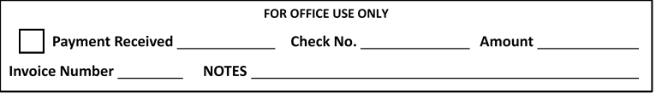

BUSINESS NAME

NAME OF EXHIBITOR(S)

ADDRESS

CITY STATE ZIP

PHONE ALTERNATIVE NO.

E-MAIL ADDRESS

WEBSITE

DESCRIBE WHAT YOU MAKE AND HOW YOU MAKE IT

REQUESTS

**PLEASE RESERVE THE FOLLOWING VENDOR BOOTH SPACE FOR ME:**

**12’ X 6’ SPACE @ $130 EACH $**

**Bring your own table and chairs TOTAL $**

**Access to electricity will be limited. Exhibitors should bring a 50’ extension cord. Electrical wattage is for displays (i.e. lighting or to plug in your product). If you need more wattage please contact us**.

**MAKE CHECK PAYABLE TO JOHN A. LOGAN COLLEGE AND MAIL TO:**

**John A. Logan College, Attn: AutumnFest, 700 Logan College Drive, Carterville, IL 62918**

**Vendor application and fees must be returned to JALC.**

**Or to make payment with your card call: Bursar 618-985-2828 ext. 9201**

***V VENDOR FEES MUST BE PAID PRIOR TO THE EVENT BY FRIDAY NOVEMBER 1, 2024.***

***NO EXCEPTIONS.***

**For more information on the event, call 618-985-2828, ext. 8343 or email** [**autumnfest@jalc.edu**](mailto:autumnfest@jalc.edu)

**Visit our website at** [**www.jalcautumnfest.com**](http://www.jalcautumnfest.com) **and JALC AutumnFest on Facebook**

*Please be informed that all vendor applications may not be accepted.*

**Carterville, IL 62918**

**November 9th & 10th, 2024**

**AUTUMNFEST VENDOR APPLICATION**

**48th Annual John A. Logan College AutumnFest**